ASDM

Assignment 2 Name – Swapnil.R. Kadam

**1) Creation of project using agile methodology (SCRUM**

**TEMPLATE).**



2) **Created 6 ISSUES (4 STORY, 1 TASK, BUG)**

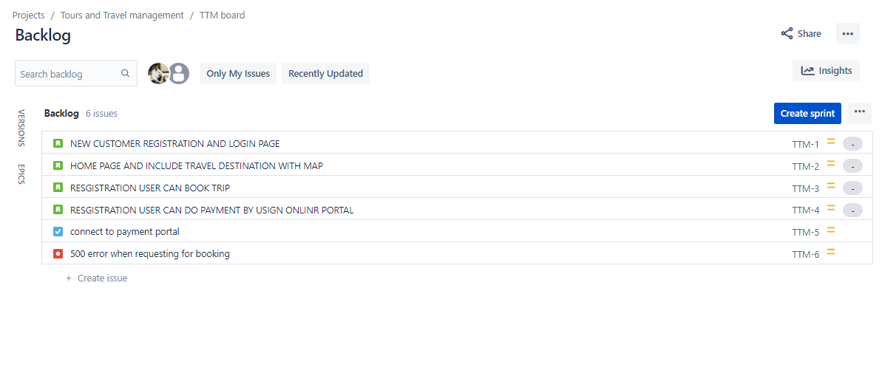

**3)** **Creation of components**

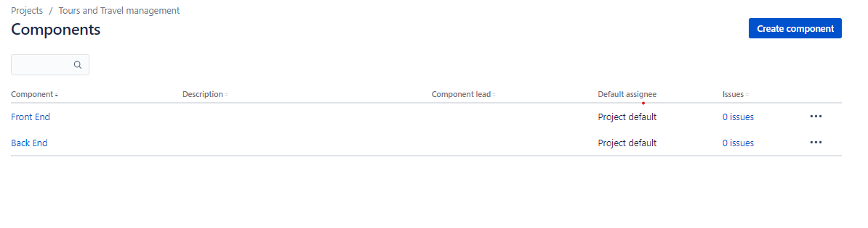

**4) Creation of version with dates**

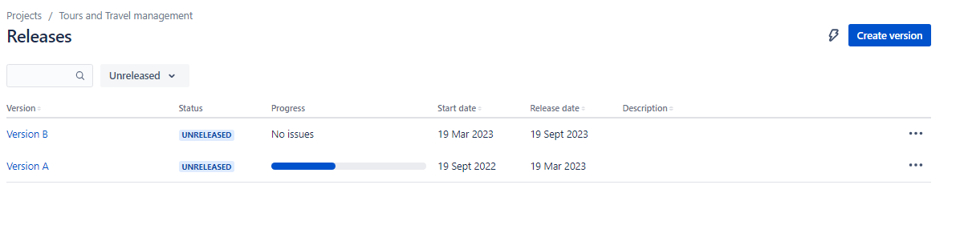

**5)** **Creation of Epic provided epic link also**

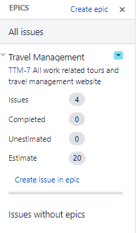 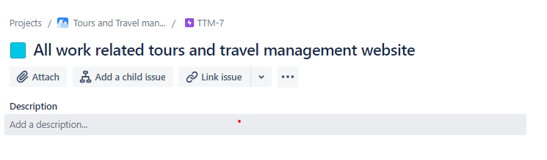

**6) Initialize story point, Associate with Version, component, estimate to Story, Subtask, task and Bug.**

**i) Initialize story point to Story and associate with version, component and link to epic**

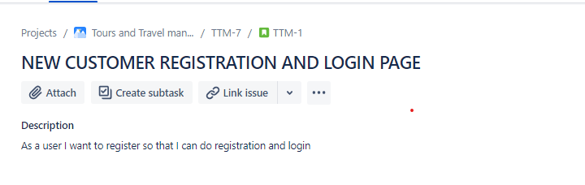

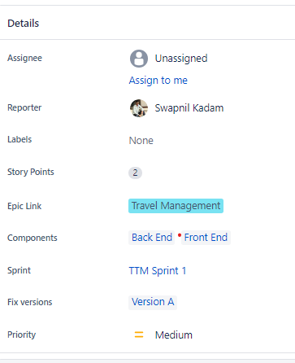

**ii) Task and Bug associate with version, component and link and give estimate time**

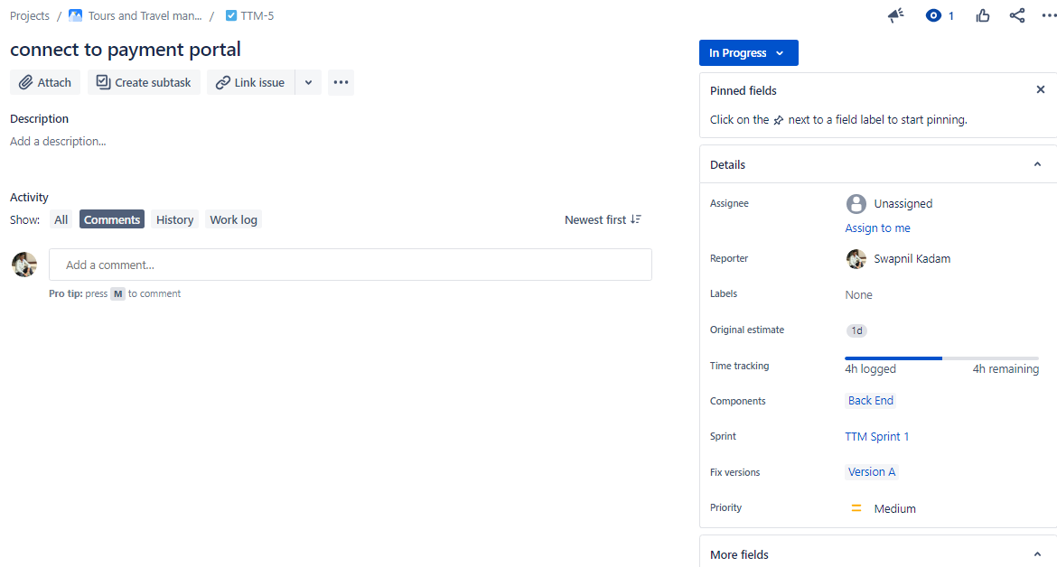

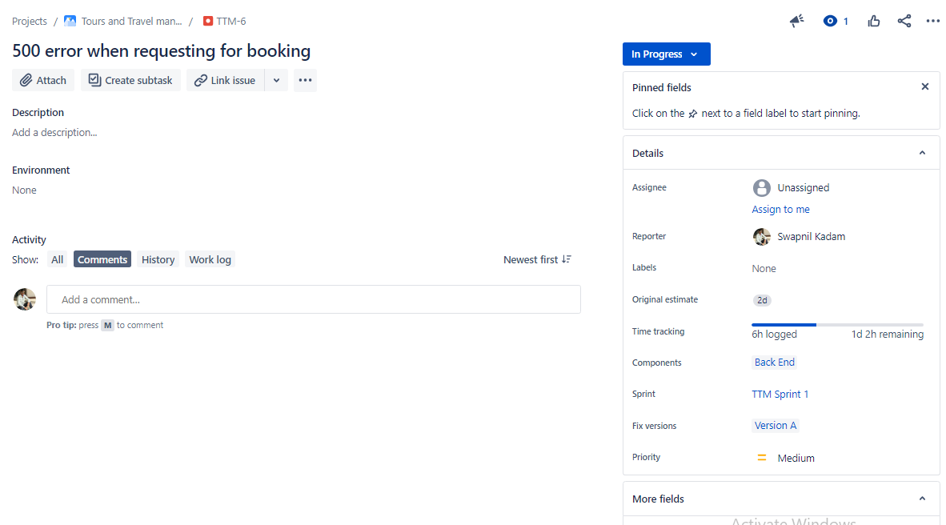

**7) Divide into sub-tasks Give estimate time**

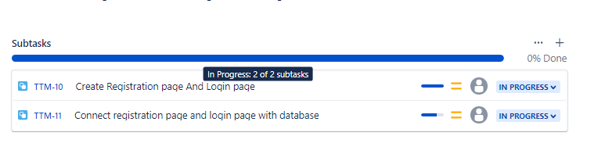

**8) Sub task associate components and version and Give estimate time**

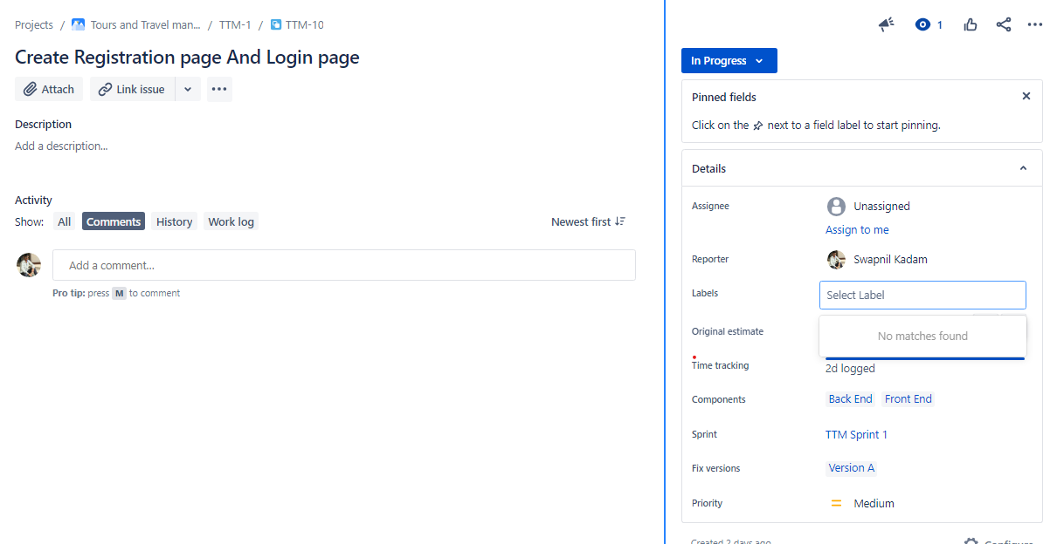

**9) Creation sprint backlog**

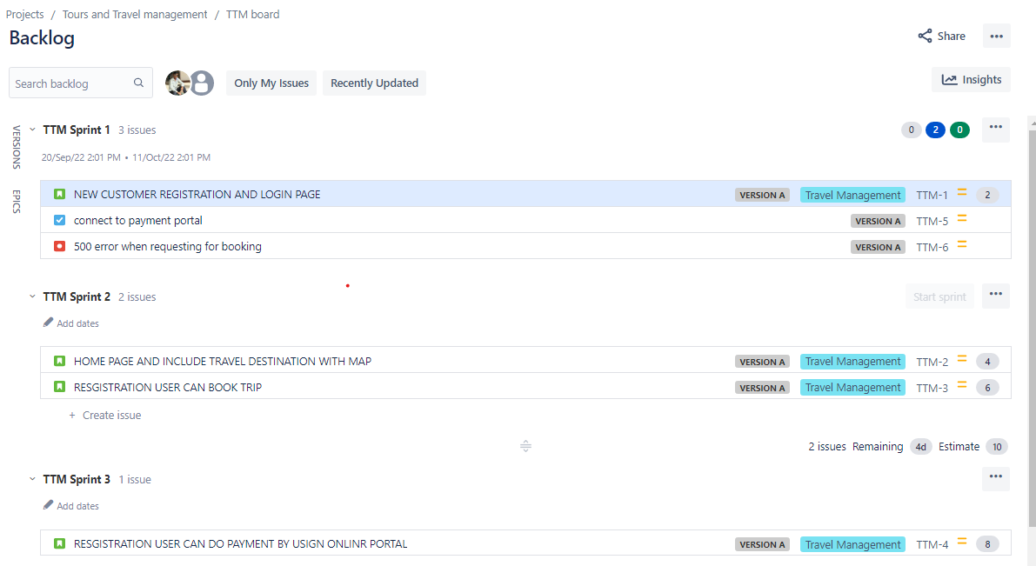

**10) Start sprint change status to progress**

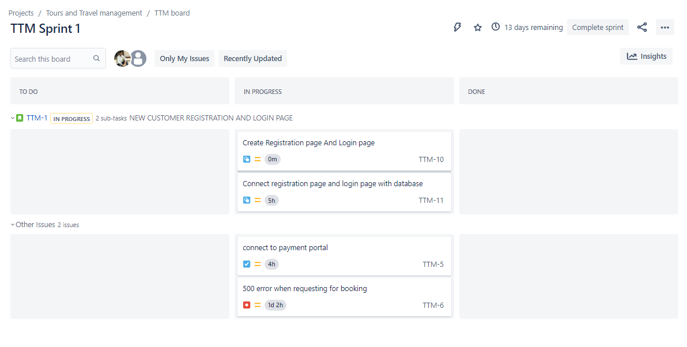

**11) Giving time log to Sub-task, task, bug.**

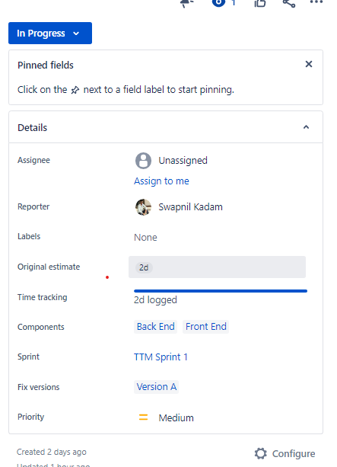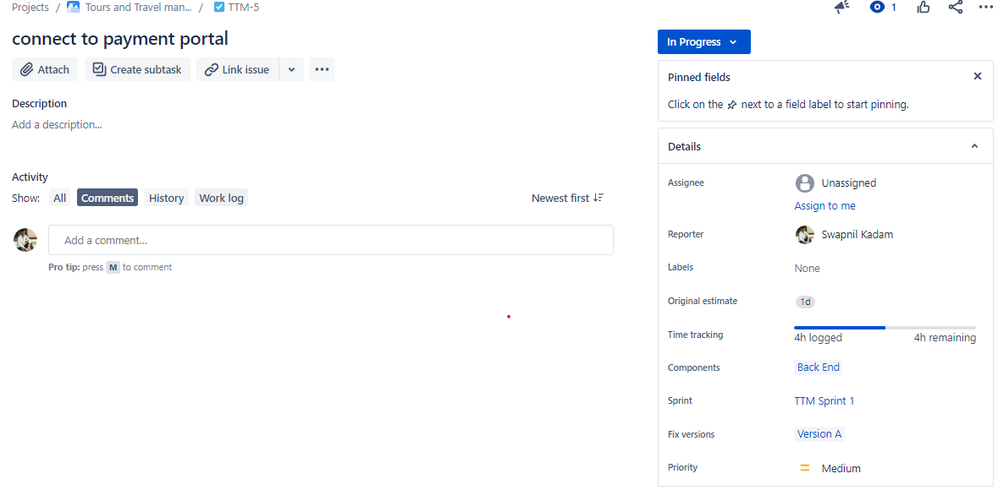

**12) Clone Story**

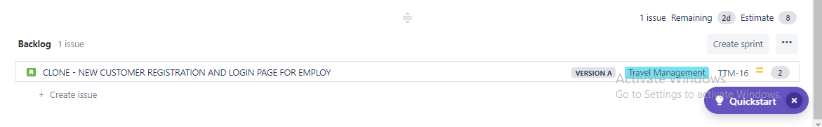

**12) Complete String**

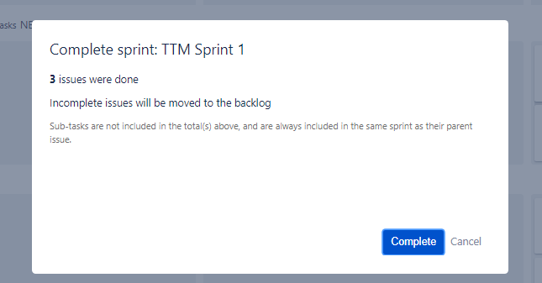

**13) Analysis burn down and burn up.**

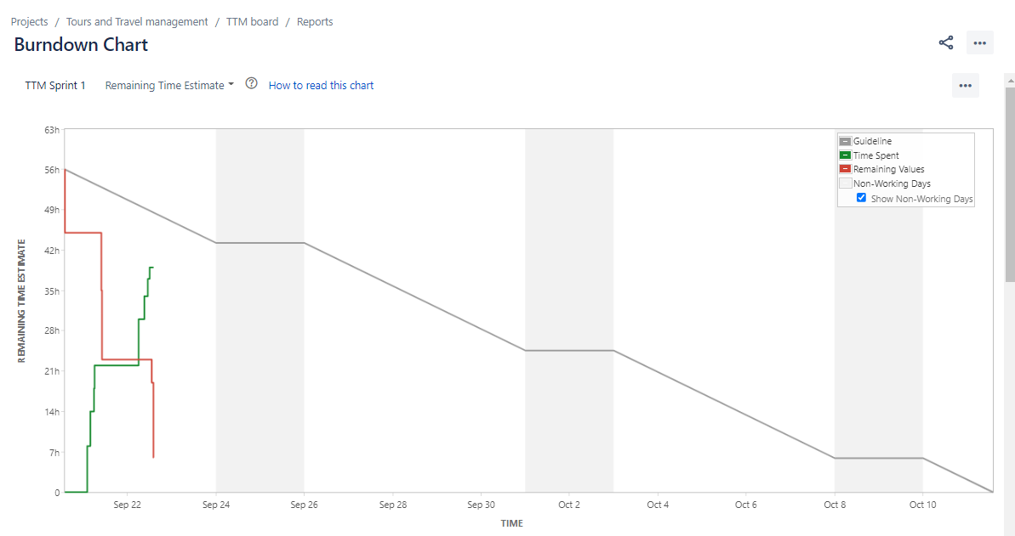

**14) Analyses the sprint report**

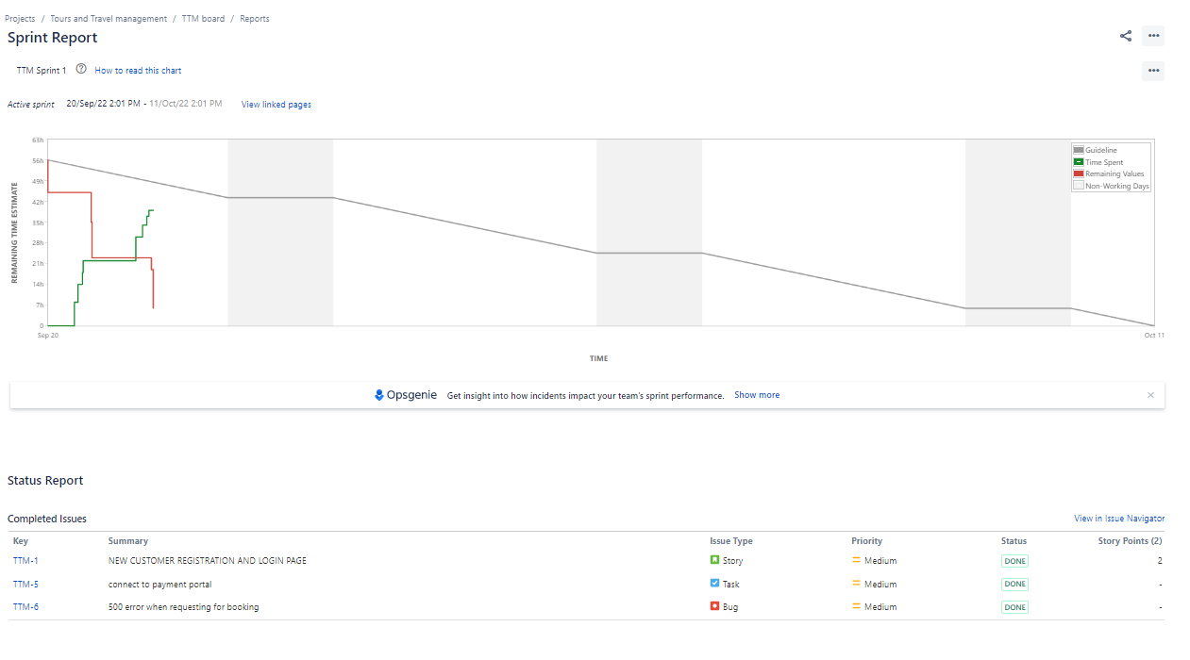

**14) Analyses the Velocity chart**

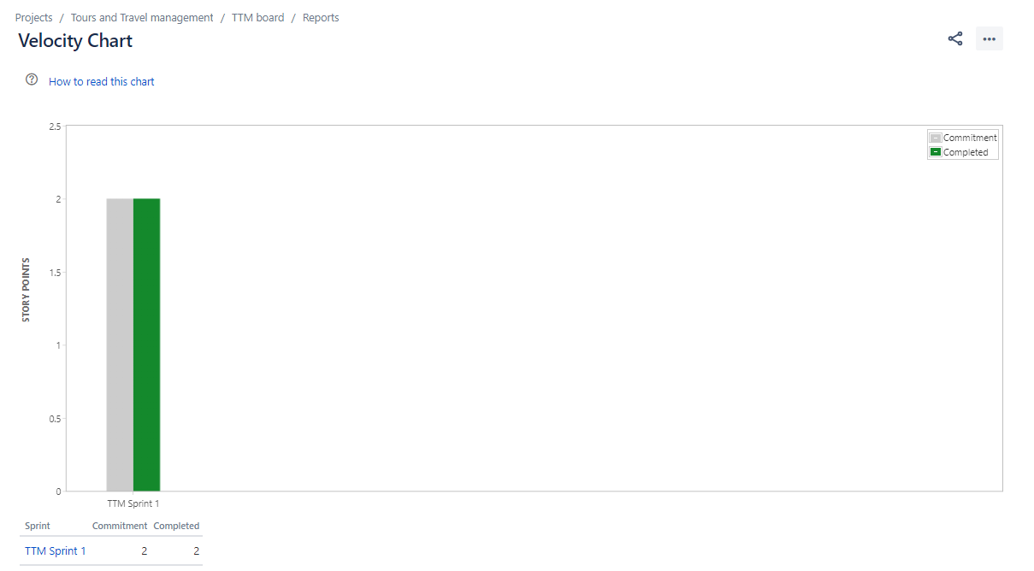

**14) Analyses the Velocity chart all 3 sprint**

